Profit & Loss Statement - Financial Analysis Using MS Excel

Aim
Built to analyze multi-year P&L performance across geographies for management reporting.

What is in Excel
This Excel shows a Profit & Loss Statement created using MS Excel. It shows Profit and Loss Statement and calculations of Total Sales, Gross Profit, EBITDA, Operating Profit, PBIT, and Net Profit per year, per quarter and per country (slicer).
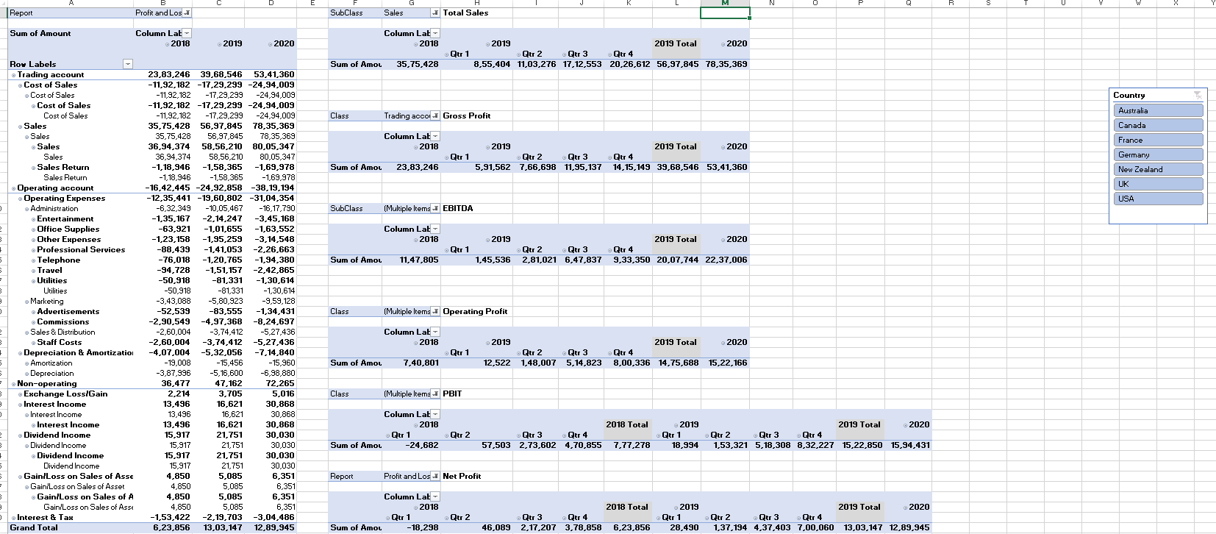

Calculations Used
Calculation of | Function Used | Filters Used | General Filters/Slicers
Total Sales | Sum of Amount | Subclass = Sales | Quarter, Year, and Country
Gross Profit | Sum of Amount | Class = Trading Account | Quarter, Year, and Country
EBITDA | Sum of Amount | Subclass = Sales, Cost of Sales, Operating Expenses | Quarter, Year, and Country
Operating Profit | Sum of Amount | Class = Trading Account, Operating Account | Quarter, Year, and Country
PBIT | Sum of Amount | Class = Trading Account, Operating Account, Non-operating Account | Quarter, Year, and Country
Net Profit | Sum of Amount | Report = Profit & Loss | Quarter, Year, and Country

Findings

Can find and compare Total Sales, Gross Profit, EBITDA, Operating Profit, PBIT, and Net Profit for three financial years for 7 countries.

Tools Used
- MS Excel Formulas, Pivot Tables, Slicers

Data Source
- Publicly available (the primary data set)
Note: Only the P&L Statement sheet is created. Other sheets are sourced.

